Luis Anunciacao, PhD
2026-10-16 - 13:38
Stability and Change in Psychosocial Risk Indicators Across Monitoring Waves in Two Brazilian Companies: Preliminary Findings From a Repeated Cross Sectional Study
Adriana Tomaz Lima, Diego Haas, Stella Torreão, Hanni Schiffer, and Luis Anunciação
Pontifícia Universidade Católica do Rio de Janeiro (PUC-Rio), Rio de Janeiro, Brazil
Abstract
Brazil’s amended Regulatory Standard No. 1 (NR-1) requires employers to identify and manage psychosocial risks, which implies assessing them repeatedly over time. This study describes the stability and change of psychosocial risk indicators across anonymous monitoring waves in two Brazilian companies. Leaders answered an inventory on the demands and resources of the leadership role at three waves between December 2025 and August 2026 (n = 21, 22 and 18). Employees answered an inventory of psychosocial work factors and mental health symptoms at two waves between December 2025 and April 2026 (n = 111 and 105). Analyses were restricted to items worded identically across waves: 8 leader items and 38 employee items. Given the short interval between waves, stability was expected. Change across waves was estimated for each item with proportional odds models adjusted for company. No leader item changed across the three waves. Among employees, 36 of 38 items were stable. Freedom to organize one’s activities (odds ratio = 0.52) and encouragement to use creativity and knowledge (odds ratio = 0.54) decreased between waves. Two of 46 tests reached p < .05, close to the number expected by chance. As expected, psychosocial risk indicators were largely stable over four to eight months. These findings are preliminary. The repeated cross sectional design, the small leader samples and the unvalidated items limit inference.
Keywords: psychosocial risk; occupational health; mental health; repeated cross sectional study; NR-1
Introduction
Psychosocial hazards at work are associated with ill health, injury and losses in productivity, and their prevention depends on how work is organized and managed (Schulte et al., 2024; World Health Organization, 2022). In a meta-review of 72 reviews with meta-analyses, job strain and long working hours were associated with depression (Niedhammer et al., 2021), and exposure to some working conditions increases the risk of the onset of depressive disorders (Rugulies et al., 2023). In Brazil, mental and behavioral disorders are among the main causes of absence from work (Bouzada et al., 2023). In 2024, Brazil amended Regulatory Standard No. 1 (NR-1) to require employers to identify, evaluate and record psychosocial risk factors in the risk inventory of their occupational risk management program (Ministério do Trabalho e Emprego, 2024). The regulation does not specify how these factors should be assessed (Ministério do Trabalho e Emprego, 2024). Despite this regulatory change, psychosocial factors at work have been described as insufficiently addressed in Brazil (de Lucca et al., 2025).
Psychosocial risk factors are conditions of work design, organization and management that can cause harm, and mental health symptoms are one possible consequence of exposure to them (International Organization for Standardization, 2021; Teixeira et al., 2025). In the Job Demands-Resources model, strain develops when job demands are high and job resources such as autonomy and supervisory support are insufficient (Bakker & Demerouti, 2007; Demerouti et al., 2001). Low work autonomy has been associated with poorer mental health (Lu et al., 2023), and persistent low job control has predicted later major depression (Taouk et al., 2024). Low freedom at work has also predicted later mental health service use (Niedhammer et al., 2026), and poor quality of leadership has predicted later mental distress (Burr et al., 2025; Fløvik et al., 2020).
Guidance on psychosocial risk management describes assessment as part of a continuing cycle of identification, action and review (International Organization for Standardization, 2021). Organizational level interventions can improve the psychosocial work environment and the health of employees (Aust et al., 2023; Rugulies et al., 2023). In Europe, national legislation on psychosocial risks has been associated with more enterprises having action plans for work related stress, and these plans with more job resources (Jain et al., 2022). Monitoring therefore requires that the same indicators be measured at successive points in time. Anonymous workforce surveys protect employees, but their responses cannot be linked over time, so successive waves describe the workforce rather than individuals (Lima et al., 2026). A recent review identified 66 mental health and well being assessments with utility for employers (Imboden et al., 2024). To our knowledge, few studies describe how psychosocial risk indicators evolve across monitoring waves in Brazilian companies.
The Current Study
Companies subject to NR-1 need evidence on whether the indicators they collect remain stable or change between assessments. The goal of this study is to describe the evolution of psychosocial risk indicators across repeated anonymous monitoring waves among leaders, assessed at three waves, and employees, assessed at two waves, in two Brazilian companies. Psychosocial risk factors reflect conditions of work design, organization and management (International Organization for Standardization, 2021; Teixeira et al., 2025), which are unlikely to change substantially within a few months. Given the short interval between waves, we expected most indicators to remain stable. The analysis is exploratory, and its results are preliminary.
Method
Design
This is a repeated cross sectional study based on secondary analysis of anonymous data from psychosocial risk monitoring conducted during the evaluation of a workplace emotion management program (Academia de Gestão da Emoção para Empresas, AGEM). The program was delivered between waves. The study does not estimate program effects. Reporting follows the STROBE guidelines for cross sectional studies (von Elm et al., 2007).
Setting and Participants
Participants were leaders and employees of two Brazilian companies. Company A is a business technology company that sells consortium plans and related financial products, and Company B is an energy trading company (Lima et al., 2026). At T1, all employees were invited (Lima et al., 2026). Because the research question concerns the evolution of risk in the workforce rather than differences between companies, the two companies were analyzed together, with company included as a covariate.
Leaders answered at three waves: from December 2025 to January 2026 (T1; n = 21), in June 2026 (T2; n = 22) and in August 2026 (T3; n = 18). Company A contributed 15, 16 and 15 leaders and Company B 6, 6 and 3. Employees answered at two waves: from December 2025 to January 2026 (T1; n = 111) and in April 2026 (T2; n = 105). Company A contributed 86 employees at each wave and Company B 25 and 19. The share of employees with less than one year in their company was 61.8% at T1 and 69.0% at T2.
Measures
Leader inventory. Twenty items covered the demands and resources of the leadership role, including decision responsibility, clarity of authority, working hours, pressure for results, conflict management, team dependence and competence, autonomy, support from senior management, emotional exposure and preparedness for situations involving team members’ mental health. Items were rated from 1 (strongly disagree) to 5 (strongly agree). An example item is “I often need to intervene in conflicts that wear down my work routine.” For the eight stable items, with positively worded items reversed, Cronbach’s α was .62 at T1, .78 at T2 and .32 at T3. Because the items cover different demands and resources, they were analyzed individually and no total score was computed.
Employee inventory. The employee inventory included 16 psychosocial work factor items covering autonomy, relationships, organizational climate and leadership support, a checklist of mental health symptoms and additional items, all rated from 1 (never) to 5 (always) (Lima et al., 2026). An example item is “Are you free to organize your activities?” Tenure in the company was recorded in six categories at both waves. Among the stable items, Cronbach’s α was .92 at T1 and .90 at T2 for the 23 symptom and emotional regulation items, with positively worded items reversed, and .88 and .91 for the 14 work factor items. Both item sets were written to cover the hazard categories named in NR-1, and their validity has not been examined (Lima et al., 2026).
Item selection. The wording of every item was compared across the online forms used at each wave, and only items worded identically at all waves were analyzed. Eight leader items met this criterion. Leader items 2, 4, 5, 6, 11, 13, 15 to 18 and 20 were reworded or negated at T2, item 10 was not asked at T2, and items present at a single wave were excluded. Thirty eight employee items met the criterion: 23 on emotional regulation and mental health symptoms, 14 on psychosocial work factors and 1 on satisfaction with oneself. Employee items 9, 39, 41, 48 and 49 were reworded at T2, and items present at a single wave were excluded. Items whose higher agreement or frequency indicates higher risk were flagged as risk items. Items were administered in Portuguese and are reported here in English translation.
Procedure
Before the first wave, a meeting with employees presented the purpose and stages of the assessment and stated that participation was voluntary and anonymous. At each wave, participants answered an anonymous online survey on SurveyMonkey. No names, email addresses, job titles or work units were recorded, and results were returned to each company only in aggregate (Lima et al., 2026). The study was registered on Plataforma Brasil and approved by the Research Ethics Committee of the Instituto Nacional de Educação de Surdos (CAAE 96841525.4.0000.8137; approval number 8.651.901). Procedures followed the ethical guidelines for research in the Human and Social Sciences (Conselho Nacional de Saúde, 2016). The committee approved the informed consent form, which described the risks of participation as minimal and stated that workers could decline to participate without constraint or harm.
Data Analysis
Each item was analyzed with a proportional odds model of the five point response on wave, with company as a covariate because the share of respondents from each company differed across waves. The effect of wave was tested with a likelihood ratio test. Odds ratios (OR) with Wald 95% confidence intervals compare each later wave with T1. When the test of wave gave p < .05, pairwise contrasts between waves were estimated from the same model to give the direction of change. Tests were two sided and were not adjusted for multiplicity because the analysis is exploratory. For presentation, responses were grouped into three categories: disagree, neutral and agree for leaders (1 to 2, 3 and 4 to 5), and never or rarely, sometimes and often or always for employees. Tables 1 and 2 report the number of respondents in each category by wave for the two companies combined, with items ordered by p and risk items marked with a dagger (†). Tenure (item 57) is reported descriptively and was not tested. Internal consistency was estimated with Cronbach’s α. Analyses were conducted in R 4.3.3 with the packages ordinal 2023.12.4, emmeans 1.10.0, psych 2.4.1 and tidyverse 2.0.0. The study was not preregistered, and the analysis code is available from the corresponding author.
Results
Leaders
None of the eight leader items changed across the three waves (p from .192 to .822; Table 1). The largest descriptive shift was in decision responsibility: agreement rose from 19% at T1 to 41% at T2 and 44% at T3 (OR for T3 vs. T1 = 1.94, 95% CI [0.61, 6.16], p = .521).

Table 1
Responses of Leaders to the Stable Items by Wave
Item | Response | T1 (n = 21) | T2 (n = 22) | T3 (n = 18) | p | OR T2 [95% CI] | OR T3 [95% CI]
7. I often need to intervene in conflicts that wear down my work routine. † | (1) disagree  (2) neutral  (3) agree | 13  7  1 | 15  4  3 | 8  7  3 | .192 | 0.67 [0.23, 2.01] | 2.01 [0.64, 6.30]
19. My work requires constant decisions that affect the safety, well being or performance of other people (e.g., reallocating people, giving difficult feedback, setting priorities). † | (1) disagree  (2) neutral  (3) agree | 7  3  9 | 10  5  5 | 6  4  8 | .250 | 0.40 [0.13, 1.27] | 0.86 [0.28, 2.68]
9. I am satisfied with my team's overall performance. | (1) disagree  (2) neutral  (3) agree | 6  1  13 | 4  2  16 | 2  1  15 | .290 | 1.39 [0.46, 4.22] | 2.61 [0.77, 8.88]
1. I feel that the burden of responsibility for decisions is high. † | (1) disagree  (2) neutral  (3) agree | 10  7  4 | 7  6  9 | 6  4  8 | .521 | 1.45 [0.51, 4.19] | 1.94 [0.61, 6.16]
3. My responsibilities and limits of authority are clear (e.g., I know how far I can decide alone and when I need to escalate). | (1) disagree  (2) neutral  (3) agree | 3  1  17 | 3  2  16 | 1  2  15 | .587 | 1.59 [0.50, 5.04] | 1.76 [0.54, 5.75]
12. The team's lack of technical or behavioral preparation increases my stress level. † | (1) disagree  (2) neutral  (3) agree | 10  3  6 | 12  4  4 | 11  4  3 | .677 | 0.66 [0.21, 2.05] | 0.62 [0.20, 1.98]
8. I feel that my team depends excessively on me to solve simple problems (e.g., recurring questions that could be solved without direct supervision). † | (1) disagree  (2) neutral  (3) agree | 15  3  2 | 14  5  3 | 12  2  4 | .812 | 1.43 [0.48, 4.26] | 1.27 [0.38, 4.30]
14. I receive feedback and support from senior management when needed. | (1) disagree  (2) neutral  (3) agree | 4  4  11 | 6  1  13 | 3  5  10 | .822 | 1.19 [0.38, 3.72] | 1.45 [0.45, 4.70]
Note. OR = odds ratio; CI = confidence interval.
Figure 1 shows the percentage of leaders who partly or strongly agreed with each item. Among the five risk items, agreement was higher at T3 than at T1 for item 1 (19% to 44%), item 7 (5% to 17%) and item 8 (10% to 22%), and lower for item 12 (32% to 17%) and item 19 (47% to 44%). Agreement with the three resource items ranged from 56% to 83% across waves. None of these differences was statistically significant (Table 1).
Figure 1
Percentage of Leaders Agreeing With Each Stable Item by Wave
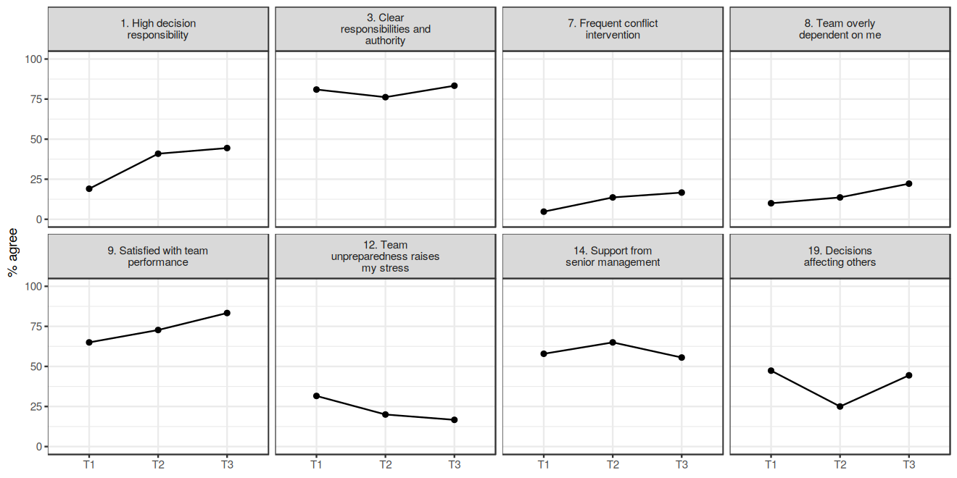

Employees
Two of the 38 employee items changed between waves (Table 2). The share answering often or always to freedom to organize one’s activities fell from 87% at T1 to 75% at T2 (OR = 0.52, 95% CI [0.31, 0.87], p = .012). For encouragement to use creativity and knowledge, it fell from 77% to 71% (OR = 0.54, 95% CI [0.33, 0.90], p = .017). The other 36 items did not change (p from .064 to .934). Across leaders and employees, 2 of 46 tests had p < .05.

Table 2
Responses of Employees to the Stable Items by Wave
Item | Response | T1 (n = 111) | T2 (n = 105) | p | OR T2 [95% CI] | Post hoc
34. Are you free to organize your activities? (e.g., choosing the order of tasks) | (1) never or rarely  (2) sometimes  (3) often or always | 4  10  97 | 6  19  77 | .012 | 0.52 [0.31, 0.87] | T1 > T2
35. Are you encouraged to use your creativity and knowledge? (e.g., suggesting improvements or new ideas) | (1) never or rarely  (2) sometimes  (3) often or always | 8  17  86 | 10  20  72 | .017 | 0.54 [0.33, 0.90] | T1 > T2
31. Are you satisfied with yourself and your choices? (e.g., believing you are on the right path) | (1) never or rarely  (2) sometimes  (3) often or always | 8  40  63 | 13  39  50 | .064 | 0.62 [0.37, 1.03]
4. Do you demand too much of yourself? (e.g., feeling that you have never done enough) † | (1) never or rarely  (2) sometimes  (3) often or always | 5  18  88 | 5  23  77 | .072 | 0.63 [0.39, 1.04]
1. Do you cope well with frustrations and unexpected events? (e.g., staying calm even when you miss a deadline) | (1) never or rarely  (2) sometimes  (3) often or always | 14  35  62 | 4  34  67 | .100 | 1.53 [0.92, 2.55]
45. Do you receive feedback to improve your performance? (e.g., clear and useful guidance) | (1) never or rarely  (2) sometimes  (3) often or always | 11  18  82 | 16  21  63 | .104 | 0.66 [0.40, 1.09]
37. Do you feel you belong to the team and the company? (e.g., feeling part of the group) | (1) never or rarely  (2) sometimes  (3) often or always | 1  16  94 | 8  15  77 | .104 | 0.65 [0.39, 1.09]
21. Have you been forgetful or had memory lapses? (e.g., forgetting appointments or names) † | (1) never or rarely  (2) sometimes  (3) often or always | 39  36  35 | 45  33  26 | .133 | 0.69 [0.43, 1.12]
2. Do you keep your self control in situations of stress or conflict? (e.g., not losing your temper in arguments) | (1) never or rarely  (2) sometimes  (3) often or always | 5  27  79 | 6  29  70 | .135 | 0.68 [0.41, 1.13]
32. Are you satisfied with your current role? (e.g., feeling that your role suits you) | (1) never or rarely  (2) sometimes  (3) often or always | 12  24  75 | 14  24  64 | .140 | 0.69 [0.42, 1.13]
33. Does the company trust your ability to make decisions? (e.g., solving problems without asking permission for everything) | (1) never or rarely  (2) sometimes  (3) often or always | 12  26  73 | 18  23  61 | .150 | 0.69 [0.42, 1.14]
17. Do you have difficulty sleeping? † | (1) never or rarely  (2) sometimes  (3) often or always | 50  30  31 | 56  33  15 | .160 | 0.71 [0.44, 1.15]
3. Can you be assertive without raising your voice or being aggressive? (e.g., saying what you need to say without shouting) | (1) never or rarely  (2) sometimes  (3) often or always | 5  15  91 | 3  19  83 | .161 | 0.69 [0.41, 1.16]
47. Does your leader show concern for your well being? (e.g., asking how you are and offering support) | (1) never or rarely  (2) sometimes  (3) often or always | 13  22  76 | 13  16  71 | .200 | 0.72 [0.44, 1.19]
44. Do you feel comfortable talking to your leader? (e.g., expressing expectations and conflicts without fear) | (1) never or rarely  (2) sometimes  (3) often or always | 5  19  87 | 11  17  72 | .226 | 0.73 [0.44, 1.21]
25. Do you have a lack or excess of appetite? (e.g., raiding the fridge at night or skipping meals) † | (1) never or rarely  (2) sometimes  (3) often or always | 38  24  49 | 41  28  35 | .256 | 0.76 [0.47, 1.22]
15. Do you have headaches or muscle pain? † | (1) never or rarely  (2) sometimes  (3) often or always | 40  20  50 | 38  29  38 | .300 | 0.78 [0.48, 1.25]
10. Do you consider yourself shy or insecure? † | (1) never or rarely  (2) sometimes  (3) often or always | 57  27  27 | 46  35  24 | .301 | 1.29 [0.80, 2.08]
6. Do you suffer in anticipation? (e.g., worrying about something that has not happened yet) † | (1) never or rarely  (2) sometimes  (3) often or always | 11  28  72 | 15  27  63 | .306 | 0.78 [0.48, 1.26]
22. Do you have stomach aches or bowel problems? † | (1) never or rarely  (2) sometimes  (3) often or always | 67  23  21 | 56  28  20 | .354 | 1.25 [0.78, 2.03]
30. Do you feel like giving up on living? (e.g., thoughts about death or not going on) † | (1) never or rarely  (2) sometimes  (3) often or always | 88  15  8 | 87  10  5 | .419 | 0.80 [0.46, 1.38]
26. Do you often feel anxiety or distress? (e.g., tightness in the chest for no clear reason) † | (1) never or rarely  (2) sometimes  (3) often or always | 40  23  48 | 37  33  34 | .467 | 0.84 [0.52, 1.35]
23. Do you have feelings of inferiority? (e.g., believing you are not good enough) † | (1) never or rarely  (2) sometimes  (3) often or always | 45  35  31 | 42  30  32 | .501 | 1.18 [0.73, 1.90]
36. Do employees respect and care about one another? (e.g., absence of humiliation or toxic competition) | (1) never or rarely  (2) sometimes  (3) often or always | 6  18  86 | 6  21  73 | .536 | 0.85 [0.52, 1.41]
24. Do you notice decreased libido? (e.g., loss of sexual interest) † | (1) never or rarely  (2) sometimes  (3) often or always | 59  29  23 | 52  31  21 | .565 | 1.15 [0.71, 1.86]
46. Do you receive adequate training? (e.g., learning what is needed to do your job) | (1) never or rarely  (2) sometimes  (3) often or always | 15  19  77 | 10  18  72 | .699 | 1.10 [0.67, 1.82]
42. Is everyone treated well regardless of personal differences? (e.g., absence of prejudice based on age, gender or ethnicity) | (1) never or rarely  (2) sometimes  (3) often or always | 6  15  90 | 4  9  87 | .716 | 1.11 [0.64, 1.89]
19. Do you perceive yourself as sad or in a depressed mood? (e.g., lack of pleasure in daily activities) † | (1) never or rarely  (2) sometimes  (3) often or always | 57  30  24 | 53  35  16 | .774 | 0.93 [0.57, 1.51]
38. Is there a sense of teamwork? (e.g., collaboration among professionals) | (1) never or rarely  (2) sometimes  (3) often or always | 2  19  90 | 5  12  83 | .788 | 1.07 [0.64, 1.79]
7. Do you dwell on past situations? (e.g., often recalling old hurts) † | (1) never or rarely  (2) sometimes  (3) often or always | 39  31  41 | 35  36  34 | .831 | 0.95 [0.59, 1.53]
27. Do you have hair loss with no apparent cause? † | (1) never or rarely  (2) sometimes  (3) often or always | 58  23  30 | 59  18  25 | .834 | 0.95 [0.59, 1.54]
40. Do employees have the same opportunities? (e.g., promotions without favoritism) | (1) never or rarely  (2) sometimes  (3) often or always | 21  25  65 | 18  21  61 | .838 | 0.95 [0.58, 1.55]
28. Do you have disturbing thoughts? (e.g., imagining negative scenarios or distressing thoughts) † | (1) never or rarely  (2) sometimes  (3) often or always | 55  23  33 | 54  24  24 | .856 | 0.96 [0.59, 1.55]
18. Do you feel unmotivated or discouraged? (e.g., no desire to start simple tasks) † | (1) never or rarely  (2) sometimes  (3) often or always | 43  44  24 | 37  50  17 | .872 | 1.04 [0.64, 1.70]
29. Have you been crying more lately? (e.g., crying over small things) † | (1) never or rarely  (2) sometimes  (3) often or always | 66  22  23 | 72  16  14 | .893 | 0.97 [0.59, 1.57]
16. Do you often feel tired? (e.g., waking up without energy even after sleeping) † | (1) never or rarely  (2) sometimes  (3) often or always | 26  27  58 | 16  41  48 | .904 | 0.97 [0.60, 1.57]
20. Do you often have difficulty concentrating? (e.g., starting tasks and not finishing them) † | (1) never or rarely  (2) sometimes  (3) often or always | 48  39  24 | 45  41  18 | .915 | 1.03 [0.63, 1.68]
43. Do you have access to adequate equipment and materials to do your tasks? | (1) never or rarely  (2) sometimes  (3) often or always | 0  11  100 | 3  5  92 | .934 | 1.03 [0.55, 1.92]
57. How long have you been working at this company? | (1) up to 6 months  (2) 6 months to 1 year  (3) 1 to 2 years  (4) 2 to 4 years  (5) 4 to 6 years  (6) more than 6 years | 47  21  21  12  7  2 | 42  27  12  12  4  3 | — | —
Note. OR = odds ratio; CI = confidence interval.

Figure 2 shows the percentage of employees answering often or always to each item, grouped into symptoms and emotional regulation (items 1 to 30), satisfaction with oneself (item 31) and psychosocial work factors (items 32 to 47). This percentage was lower at T2 than at T1 for 18 of the 20 symptom risk items, with the largest difference for difficulty sleeping (28% to 14%; p = .160). Among the 14 work factor items, it was lower at T2 for 8 items and higher for 6 items. Apart from items 34 and 35, none of these differences was statistically significant (Table 2).
Figure 2
Percentage of Employees Answering Often or Always to Each Stable Item by Wave
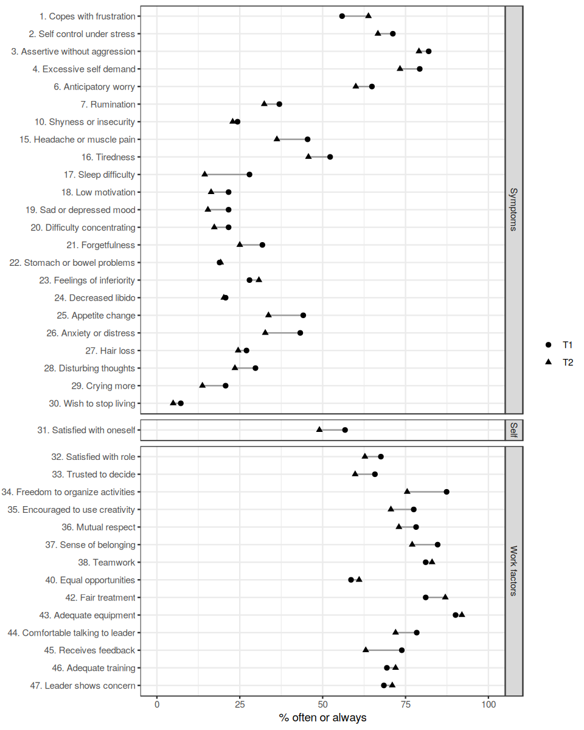
Discussion
Companies subject to NR-1 need to know whether the psychosocial risk indicators they collect remain stable between assessments. This study described the evolution of these indicators across anonymous monitoring waves among leaders and employees of two Brazilian companies. As expected, most indicators were stable. No leader item changed over three waves, and 36 of 38 employee items did not change between two waves. The two changes concerned job resources: freedom to organize one’s activities and encouragement to use creativity and knowledge decreased among employees.
The predominance of stability is consistent with our expectation and with the view of psychosocial risk factors as conditions of work design, organization and management (International Organization for Standardization, 2021; Teixeira et al., 2025), which may change slowly over a few months. Scales of psychosocial work factors have shown acceptable test retest reliability among Brazilian workers (Gonçalves et al., 2021), so stable responses are expected when working conditions do not change. Two significant results among 46 tests is close to the 2.3 expected by chance at α = .05, so the overall pattern is better described as stability than as change.
Both items that changed describe autonomy, a job resource in the Job Demands-Resources model (Bakker & Demerouti, 2007; Demerouti et al., 2001). Low work autonomy has been associated with poorer mental health (Lu et al., 2023). In the present data, the decrease in autonomy items was not accompanied by changes in the symptom items. This pattern may indicate that a reduction in resources had not yet been reflected in symptoms, that the change was too small to affect them or that the two results are chance findings. In a prospective cohort, persistent low job control showed a stronger association with later major depression than intermittent low job control (Taouk et al., 2024). A short reduction in autonomy may therefore not be reflected in symptoms within a few months.
The absence of change among leaders should be read in light of the sample sizes. With about 20 leaders per wave, the confidence intervals of the odds ratios were wide, and only large shifts could be detected. The internal consistency of the leader items was also low and unstable across waves, which supports their analysis as separate indicators. Leadership quality has predicted later mental distress among employees (Burr et al., 2025; Fløvik et al., 2020), so monitoring the demands placed on leaders remains relevant even when small samples limit statistical inference.
The item selection step removed 12 of the 20 leader items and 5 of the 43 employee items asked at both waves, because their wording changed between waves. This loss illustrates a practical requirement for monitoring under NR-1: item wording should be fixed before the first wave and kept unchanged, so that later waves can be compared with the first.
Limitations
The design was repeated cross sectional. Responses could not be linked across waves, so changes in the composition of the respondents cannot be separated from changes within individuals. Adjusting for company addresses differences between companies but not turnover within them; the share of employees with less than one year in their company rose from 61.8% to 69.0%. The leader samples were small, with 18 to 22 respondents per wave. The proportional odds assumption was not tested. The items have not been validated (Lima et al., 2026). The program delivered between waves and the absence of a comparison group prevent any causal interpretation of change or stability. All data were self reported, which exposes the comparisons to common method bias (Podsakoff et al., 2003). For these reasons, the results should be regarded as preliminary.
Future Directions
Future monitoring should fix item wording across waves, use anonymous linking codes that allow responses to be matched over time, and include more waves to describe trajectories rather than pairwise differences. Validated scale scores would allow change to be estimated on constructs rather than single items.
Conclusion
These preliminary results show that, across four to eight months, psychosocial risk indicators among leaders and employees of two Brazilian companies were largely stable, as expected given the short interval. The only changes were decreases in two job resource items among employees.
References
Aust, B., Møller, J. L., Nordentoft, M., Frydendall, K. B., Bengtsen, E., Jensen, A. B., Garde, A. H., Kompier, M., Semmer, N., Rugulies, R., & Jaspers, S. Ø. (2023). How effective are organizational-level interventions in improving the psychosocial work environment, health, and retention of workers? A systematic overview of systematic reviews. Scandinavian Journal of Work, Environment & Health, 49(5), 315–329. https://doi.org/10.5271/sjweh.4097
Bakker, A. B., & Demerouti, E. (2007). The Job Demands-Resources model: State of the art. Journal of Managerial Psychology, 22(3), 309–328. https://doi.org/10.1108/02683940710733115
Bouzada, D. F., Sol, N. A. A., & da Silva, C. A. M. (2023). Absenteeism due to mental and behavioral disorder in employees of a federal university. Revista Brasileira de Medicina do Trabalho, 20(4), 515–523. https://doi.org/10.47626/1679-4435-2022-763
Burr, H., Kersten, N., Sørensen, K., Sørensen, J. K., Dalsager, L., Madsen, I. E. H., Schöllgen, I., d’Errico, A., Rose, U., & Rugulies, R. (2025). A comparison among employees in Germany and Denmark of associations between quality of leadership and subsequent 5-year development of mental distress. Scientific Reports, 15(1), 7802. https://doi.org/10.1038/s41598-025-92650-0
Conselho Nacional de Saúde. (2016). Resolução nº 510, de 7 de abril de 2016. Dispõe sobre as normas aplicáveis a pesquisas em Ciências Humanas e Sociais. Diário Oficial da União. https://bvsms.saude.gov.br/bvs/saudelegis/cns/2016/res0510_07_04_2016.html
de Lucca, S. R., Silva Junior, J. S., & Bandini, M. (2025). Critical analysis of psychosocial factors at work within the Risk Management Program of Regulatory Standard-1. Revista Brasileira de Medicina do Trabalho, 23(1), e20251425. https://doi.org/10.47626/1679-4435-2025-1425
Demerouti, E., Bakker, A. B., Nachreiner, F., & Schaufeli, W. B. (2001). The job demands-resources model of burnout. Journal of Applied Psychology, 86(3), 499–512. https://doi.org/10.1037/0021-9010.86.3.499
Fløvik, L., Knardahl, S., & Christensen, J. O. (2020). How leadership behaviors influence the effects of job predictability and perceived employability on employee mental health: A multilevel, prospective study. Scandinavian Journal of Work, Environment & Health, 46(4), 392–401. https://doi.org/10.5271/sjweh.3880
Gonçalves, J. S., Moriguchi, C. S., Chaves, T. C., & Sato, T. O. (2021). Cross-cultural adaptation and psychometric properties of the short version of COPSOQ II-Brazil. Revista de Saúde Pública, 55, 69. https://doi.org/10.11606/s1518-8787.2021055003123
Imboden, M. T., Wolfe, E., Evers, K., Ferrão, A., Mochari-Greenberger, H., Johnson, S., Kirsten, W., & Seaverson, E. L. D. (2024). Evaluating workforce mental health and well-being: A review of assessments. American Journal of Health Promotion, 38(4), 540–559. https://doi.org/10.1177/08901171231223786
International Organization for Standardization. (2021). Occupational health and safety management: Psychological health and safety at work: Guidelines for managing psychosocial risks (ISO Standard No. 45003:2021). https://www.iso.org/standard/64283.html
Jain, A., Torres, L. D., Teoh, K., & Leka, S. (2022). The impact of national legislation on psychosocial risks on organisational action plans, psychosocial working conditions, and employee work-related stress in Europe. Social Science & Medicine, 302, 114987. https://doi.org/10.1016/j.socscimed.2022.114987
Lima, A. T., Haas, D., Torreão, S., Schiffer, H., & Anunciação, L. (2026). Psychosocial work factors and mental health symptoms under NR-1: A feasibility study [Manuscript submitted for publication]. Departamento de Psicologia, Pontifícia Universidade Católica do Rio de Janeiro.
Lu, Z., Wang, S., Li, Y., Liu, X., & Olsen, W. (2023). Who gains mental health benefits from work autonomy? The roles of gender and occupational class. Applied Research in Quality of Life, 1–23. https://doi.org/10.1007/s11482-023-10161-4
Ministério do Trabalho e Emprego. (2024). Portaria MTE nº 1.419, de 27 de agosto de 2024. Aprova a nova redação do capítulo 1.5 "Gerenciamento de Riscos Ocupacionais" e altera o Anexo I "Termos e Definições" da Norma Regulamentadora nº 1. Diário Oficial da União. https://www.gov.br/trabalho-e-emprego/pt-br/assuntos/inspecao-do-trabalho/seguranca-e-saude-no-trabalho/sst-portarias/2024/portaria-mte-no-1-419-nr-01-gro-nova-redacao.pdf
Niedhammer, I., Bertrais, S., & Witt, K. (2021). Psychosocial work exposures and health outcomes: A meta-review of 72 literature reviews with meta-analysis. Scandinavian Journal of Work, Environment & Health, 47(7), 489–508. https://doi.org/10.5271/sjweh.3968
Niedhammer, I., Quatrevaux, M., & Bertrais, S. (2026). Psychosocial work factors and subsequent mental health service use: A prospective study using the national ESPS survey in France. European Journal of Public Health, 36(2). https://doi.org/10.1093/eurpub/ckag012
Podsakoff, P. M., MacKenzie, S. B., Lee, J.-Y., & Podsakoff, N. P. (2003). Common method biases in behavioral research: A critical review of the literature and recommended remedies. Journal of Applied Psychology, 88(5), 879–903. https://doi.org/10.1037/0021-9010.88.5.879
Rugulies, R., Aust, B., Greiner, B. A., Arensman, E., Kawakami, N., LaMontagne, A. D., & Madsen, I. E. H. (2023). Work-related causes of mental health conditions and interventions for their improvement in workplaces. The Lancet, 402(10410), 1368–1381. https://doi.org/10.1016/S0140-6736(23)00869-3
Schulte, P. A., Sauter, S. L., Pandalai, S. P., Tiesman, H. M., Chosewood, L. C., Cunningham, T. R., Wurzelbacher, S. J., Pana-Cryan, R., Swanson, N. G., Chang, C.-C., Nigam, J. A. S., Reissman, D. B., Ray, T. K., & Howard, J. (2024). An urgent call to address work-related psychosocial hazards and improve worker well-being. American Journal of Industrial Medicine, 67(6), 499–514. https://doi.org/10.1002/ajim.23583
Taouk, Y., Aitken, Z., LaMontagne, A. D., & King, T. (2024). Persistent low job control and subsequent major depression: A prospective cohort study of Australian working males. Social Science & Medicine, 359, 117283. https://doi.org/10.1016/j.socscimed.2024.117283
Teixeira, I. D. N., Silva, I. S., & Cadime, I. M. D. (2025). Psychosocial risks at work: Integrative review and conceptual perspectives. Revista Brasileira de Medicina do Trabalho, 23(2), e20251464. https://doi.org/10.47626/1679-4435-2025-1464
von Elm, E., Altman, D. G., Egger, M., Pocock, S. J., Gøtzsche, P. C., & Vandenbroucke, J. P. (2007). The Strengthening the Reporting of Observational Studies in Epidemiology (STROBE) statement: Guidelines for reporting observational studies. The Lancet, 370(9596), 1453–1457. https://doi.org/10.1016/S0140-6736(07)61602-X
World Health Organization. (2022). WHO guidelines on mental health at work. https://www.who.int/publications/i/item/9789240053052

